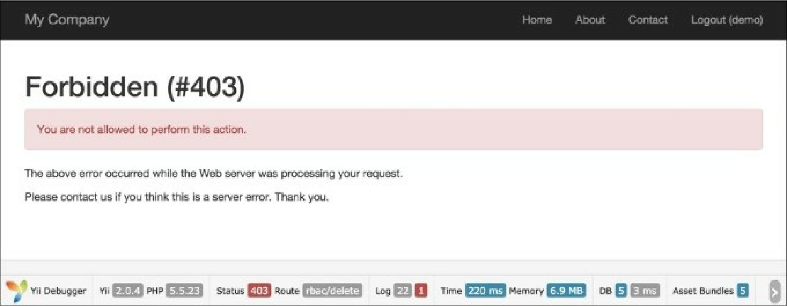

Log in as admin and run rbac/delete:

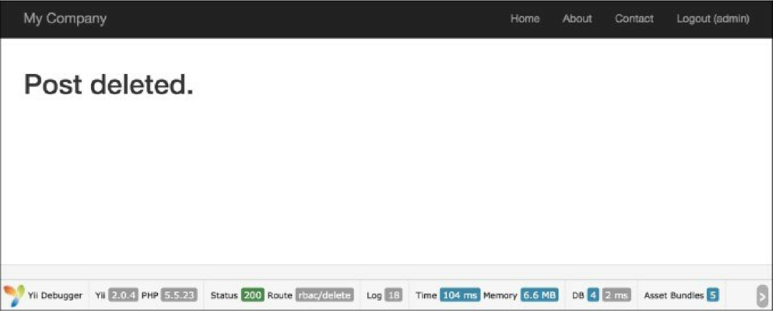

9.

How it works...

Yii implements a general hierarchical RBAC following the nist rbac model. It provides RBAC functionality through the authManagerapplication component.

The RBAC hierarchy is a directed acyclic graph, that is, a set of nodes and their directed connections or edges. There are three types of node available: roles, permissions, and rules.

A role represents a collection of permissions (for example creating posts and updating posts). A role may be assigned to one or multiple users. To check if a user has a specified permission, we may check whether